WEB GRAPHICS
Comprehensive Written Test
Name:
What is HTML?

What is the W3C?

What is a browser?

What are tags?

What do these tags do? <html></html>
<head></head>
<body></body>
<body bgcolor="pink">
<body text="black">
<hl></hl>
<h6></h6>
<img src="../benjyGoogle copy.png">
<p></p>
<p align="center">

Why do tags have two parts: <tag> and </tag>?
How do you make <h1> centered?

How do you change the color of a font?

How do you make text bold?

How do you make text italic?

Can you make text italic and bold?

If so, how?

How do you make text into a link?

How do you make an image into a link?

How do you make a linked page open in a new window?

How do you change the width of a horizontal rule?

What is a pixel?

What is a "thumbnail"?

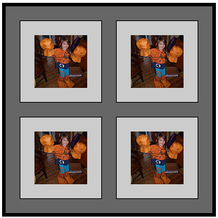

Identify the following by writing “light gray”, “dark gray” or “black” after each.

Cell padding:

Cell spacing:

Border:

How do you make a cell span several columns?

Why do we need <alt> and <title>?

What are the hexadecimal codes for these colors?
White Black

What are these tags?

<td>

<a href="*content*">

What is a div?

What does it mean to be “deprecated”?

How would you make a div have a different color text?

How would you make a div have a different color background?

What is the difference between these two colors: #fff and #ffffff?

How would you make a div that is 800px wide, black background, white text, and has 20px padding? (2 points)

How do you align a div’s content to the right, instead of the left?

What is this?

<!--*content* -->

What is it for?

What are all of these areas?

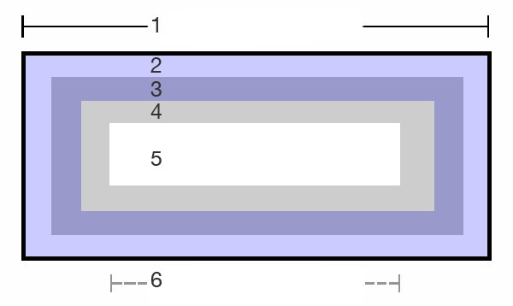
1.

2.

3.

4.

5.

6.

What does it mean to say that div is “taken out of the normal flow”?

What is absolute positioning?

What is relative positioning?

How do you move a div 50px down and 100px to the right?

How would you put a div all the way on the top left of the webpage?

What is a “nested” div?

If a div is contained inside another div, and has this code, where will it fall on the page?
<div style=”position:absolute;top:0:left:0;margin:0 0 0 50px;”>

What does <div style=”float:left”> do?

How can you make two divs overlap one another?

What is a container div?

How do you center a container div on the page?

What will this do?
<div align=”center”></div>

If you’re making a container div, and you want to put a bunch of other divs inside it, should those divs be positioned relatively, or absolutely?

If you want your content to flow around a nav bar, you will need to make two separate divs. How are they arranged? Is one inside the other, and if so, how? (2 points)

What “special” tag will you need to add to the nav bar?

How do you define a minimum height for a div?

Why would you want to define a minimum height for div?

What does this tag do?
<div style=”clear:both”>

What is a server?

Where is a server located?

What is the difference between “local” and “remote” files?

What is web hosting?

What is a domain name?

What does URL stand for?

What is DNS?

What does FTP stand for? What does it do?

What is an index page?

What does optimization mean?

What are the three places you can change the formatting of a page element? (three points)

What is the code used for creating a style in the header?

Correct the syntax of the this style: (2 points)
body (
font size="2px"
font color="red"
)

What does this do? (2 points)
h1, h2{color:#fff;font-family:serif;}

What does this do?
a {text-decoration: none;}

Why is there more than one font listed here?
font-family: Georgia, Times New Roman, Times, serif;

What's wrong with this code?
font-family:acidhouse, base02, jihadi;

What is the difference between a class and an id?

What's wrong with this code? (3 points)

<html>
<head>
<style type="text/css">
.main{
margin:20px;
padding:10px;
color:#FFF
background:#000;
}
</style>
</head>
<body>
<div id="main">*content*</div>
</body>
</html>

What’s the difference between an internal and an external style sheet?

What is the file extension for external style sheets?

How is the syntax of external style sheets different from the syntax of internal style sheets?

Your external style sheet says this:
h1{color:blue;}
Your internal style sheet says this:
h1{color:yellow;}
The body of your document says this:
<h1><font-color:red;>Cows!!!</font></h2>
What color is the word “Cows!!!” ?
Why?

Using CSS, what are three ways to specify type size in a website (measurements)?
1.
2.
3.
Using CSS, how do you accomplish the following? (write valid code)
Make the default paragraph text italic?
Make the default paragraph text bold?
Make an id for footer text that made it white Palatino.
Make a class for indented text?
Make the default link style have no underline?
Make the default unordered list have no bullets?
What are the four selectors for links?
1.
2.
3.
4.

What is PHP?
What is a server-side script?
If you created a php include for a navigation bar, how would you save the navigation bar?
How would you link to it? (write valid code)
What other uses are there for PHP?

What is optimization?
What are five things you can do to improve your optimization?
1.
2.
3.
4.
5.
What are analytics?
How do you use them?

FLASH
What is a timeline?
What are frames?
What is a keyframe?
What are layers?
What is a tween?
What is an action?
What is fps?
What is the difference between a .fla file and a .swf file?
What is a movie clip?
What is a mask?
In AS2, how do you make an animation stop? (write valid code)
What is an alpha tween?
What is the difference between a graphic object and a bitmap image?
What is the correct ending (suffix) for button names in flash?

